**Database**:

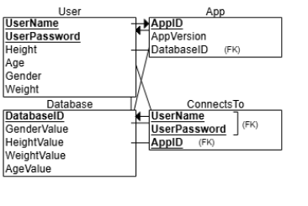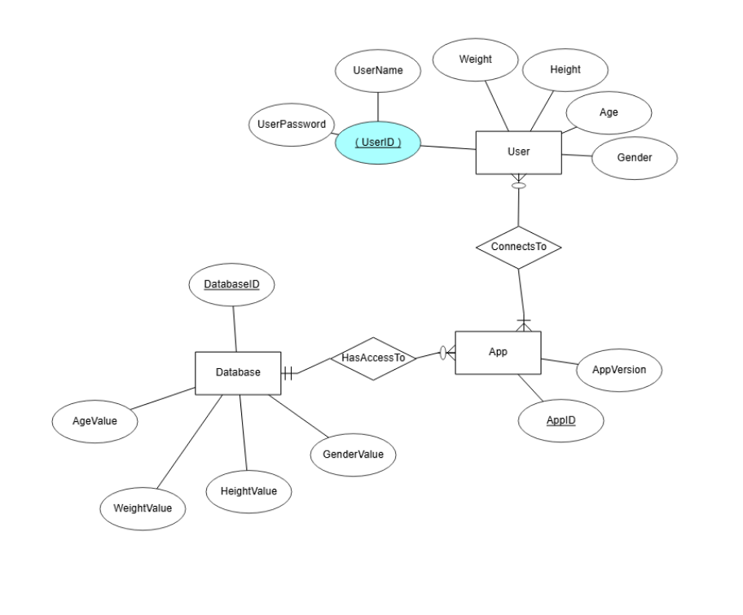  
  
Each user will have several attributes that are tied to their account. These attributes are weight, height, age, and gender. Each user also has a unique login consisting of an username and a password. Each user needs to connect to at least one app. The app has an appID and an app version. This app must have access to one database which holds the values for user attributes. The database may be accessed by many apps.